Karnatak Law Society’s

GOGTE INSTITUTE OF TECHNOLOGY

Udyambag Belagavi -590008

Karnataka, India.



A Course Project Report on

**Library Management System**

Submitted for the requirements of 3rd semester B.E. in CSE

for **“OOPS with JAVA (18CS34)”**

**Submitted by**

**NAME:** **Ms.** **Shradha M Patil USN:** **2GI20CS144**

**Ms. Srushti B Mudennavar 2GI20CS158**

**Mr. Vinit Gunaki 2GI20CS181**

**Mr. Yash Herekar 2GI20CS184**

**Under the guidance of**

**Mrs. Namita Bhat**

**Asst. Prof., Dept. of CSE**

**Academic Year 2021 - 22(Odd semester)**

**CERTIFICATE**



This is to certify that the project entitled “**Library management System**” for **“OOPS with JAVA (18CS34)”** is a bonafide record of the project work done by  **Ms**. **Shradha M Patil** (**2GI20CS144), Ms. Srushti B Mudennavar (2GI20CS158), Mr. Vinit Gunaki (2GI20CS181), Ms. Yash Herekar (2GI20CS184)** under my supervision and guidance, in partial fulfillment of the requirements for the Outcome Based Education Paradigm in Computer science and Engineering from Gogte Institute of Technology for the academic year 2021-2022.

**Under the guidance of**

**Mrs. Namita Bhat**

**Prof. Dept. CSE**

**KLS Gogte Institute of technology**

**Belagavi**

**Table of contents**

**S.No. Content Page No.**

1. Name/Title of the project
2. Statement of the Problem
3. Objectives and scope of the project
4. Hardware and software to be used
5. Methodology / Algorithm / Pseudocode
6. Screenshots
7. Conclusion
8. References

**Guide’s Name : Signature**

**Mrs. Namita Bhat**

**Marks allocation:**

|  |  |  |  |  |  |  |
| --- | --- | --- | --- | --- | --- | --- |
|  | Batch No. : | | | | | |
| 1. | Project Title: Library Management System | Marks Range | USN | | | |
|  |  |  |  |
| 2. | Problem statement (PO2) | 0-1 |  |  |  |  |
| 3. | Objectives of Defined Problem statement (PO1,PO2) | 0-2 |  |  |  |  |
| 4. | Design / Algorithm/Flowchart/Methodology (PO3) | 0-3 |  |  |  |  |
| 5. | Implementation details/Function/Procedures/Classes and Objects (Language/Tools) (PO1,PO3,PO4,PO5) | 0-4 |  |  |  |  |
| 6. | Working model of the final solution (PO3,PO12) | 0-5 |  |  |  |  |
| 7. | Report and Oral presentation skill (PO9,PO10) | 0-5 |  |  |  |  |
|  | Total | 20 |  |  |  |  |

**Title:**

Library Management System using java swing.

**Statement of the problem:**

E-Library Management System where the user has the following options:

Add book information.

Display book information.

To list all books of a given author.

To list the issued and returned books in the library.

**Objectives:**

1. No need to handle large chunks of code, therefore decreasing the complexity of programming.
2. Provides GUI (graphical user interface) based editor for easier understanding

**Hardware and software to be used:**

[Netbeans](https://www.geeksforgeeks.org/what-will-be-the-best-java-ides-in-2020/) is used to create GUI applications since it’s a well crafted open-source IDE that provides features of a Component inspector, Drag-and-Drop of widgets, Debugger, Object browser, etc.

MySQL to create the required Database

**Methodology:**

* We create a welcome page to library management system where the librarian enters the username and password.
* After login, the librarian is directed to the home page where he can register a student with proper details, add some books to the library, keep track of the issued book and books to be returned, issue a book to the registered student, and ask to return the book before the due date.
* Databases are created to store the information of the registered Students, newly added books, and issued books using MySQL server.
* Meaningful messages are displayed for successful login, a successful registration and a successful issue/returning the book.
* SQL Exceptions are handled with a meaningful message displayed to the user or the librarian.

**Code:**

**For Login class:**

import javax.swing.JFrame;

import javax.swing.JOptionPane;

public class login extends javax.swing.JFrame {

public login() {

initComponents();

}

@SuppressWarnings("unchecked")

// <editor-fold defaultstate="collapsed" desc="Generated Code">

private void initComponents() {

jLabel1 = new javax.swing.JLabel();

jLabel2 = new javax.swing.JLabel();

jTextField1 = new javax.swing.JTextField();

jPasswordField1 = new javax.swing.JPasswordField();

jButton1 = new javax.swing.JButton();

jButton2 = new javax.swing.JButton();

jLabel3 = new javax.swing.JLabel();

setDefaultCloseOperation(javax.swing.WindowConstants.EXIT_ON_CLOSE);

setLocation(new java.awt.Point(500, 500));

getContentPane().setLayout(new org.netbeans.lib.awtextra.AbsoluteLayout());

jLabel1.setBackground(new java.awt.Color(204, 204, 204));

jLabel1.setFont(new java.awt.Font("Times New Roman", 1, 14)); // NOI18N

jLabel1.setText("Username");

getContentPane().add(jLabel1, new org.netbeans.lib.awtextra.AbsoluteConstraints(440, 200, -1, -1));

jLabel2.setBackground(new java.awt.Color(204, 204, 204));

jLabel2.setFont(new java.awt.Font("Times New Roman", 1, 14)); // NOI18N

jLabel2.setText("Password");

getContentPane().add(jLabel2, new org.netbeans.lib.awtextra.AbsoluteConstraints(440, 240, 62, 28));

jTextField1.setBackground(new java.awt.Color(204, 204, 204));

jTextField1.setFont(new java.awt.Font("Times New Roman", 1, 14)); // NOI18N

jTextField1.addActionListener(new java.awt.event.ActionListener() {

public void actionPerformed(java.awt.event.ActionEvent evt) {

jTextField1ActionPerformed(evt);

}

});

getContentPane().add(jTextField1, new org.netbeans.lib.awtextra.AbsoluteConstraints(520, 200, 250, -1));

jPasswordField1.setBackground(new java.awt.Color(204, 204, 204));

jPasswordField1.setFont(new java.awt.Font("Times New Roman", 1, 14)); // NOI18N

getContentPane().add(jPasswordField1, new org.netbeans.lib.awtextra.AbsoluteConstraints(520, 240, 250, -1));

jButton1.setBackground(new java.awt.Color(204, 204, 204));

jButton1.setFont(new java.awt.Font("Times New Roman", 1, 14)); // NOI18N

jButton1.setText("Login");

jButton1.addActionListener(new java.awt.event.ActionListener() {

public void actionPerformed(java.awt.event.ActionEvent evt) {

jButton1ActionPerformed(evt);

}

});

getContentPane().add(jButton1, new org.netbeans.lib.awtextra.AbsoluteConstraints(520, 280, 100, -1));

jButton2.setBackground(new java.awt.Color(204, 204, 204));

jButton2.setFont(new java.awt.Font("Times New Roman", 1, 14)); // NOI18N

jButton2.setText("Close");

jButton2.addActionListener(new java.awt.event.ActionListener() {

public void actionPerformed(java.awt.event.ActionEvent evt) {

jButton2ActionPerformed(evt);

}

});

getContentPane().add(jButton2, new org.netbeans.lib.awtextra.AbsoluteConstraints(670, 280, 100, -1));

jLabel3.setBackground(new java.awt.Color(204, 204, 204));

jLabel3.setFont(new java.awt.Font("Times New Roman", 1, 36)); // NOI18N

jLabel3.setText("LOGIN");

getContentPane().add(jLabel3, new org.netbeans.lib.awtextra.AbsoluteConstraints(530, 130, -1, -1));

pack();

}// </editor-fold>

private void jTextField1ActionPerformed(java.awt.event.ActionEvent evt) {

}

private void jButton1ActionPerformed(java.awt.event.ActionEvent evt) {

if(jTextField1.getText().equals("2gi20cs184") && jPasswordField1.getText().equals("2gi20cs184")){

setVisible(false);

new home().setVisible(true);

} else

JOptionPane.showMessageDialog(null,"Incorrect Username or Password");

}

private void jButton2ActionPerformed(java.awt.event.ActionEvent evt) {

System.exit(0);

}

public static void main(String args[]) {

try {

for (javax.swing.UIManager.LookAndFeelInfo info : javax.swing.UIManager.getInstalledLookAndFeels()) {

if ("Nimbus".equals(info.getName())) {

javax.swing.UIManager.setLookAndFeel(info.getClassName());

break;

}

}

} catch (ClassNotFoundException ex) {

java.util.logging.Logger.getLogger(login.class.getName()).log(java.util.logging.Level.SEVERE, null, ex);

} catch (InstantiationException ex) {

java.util.logging.Logger.getLogger(login.class.getName()).log(java.util.logging.Level.SEVERE, null, ex);

} catch (IllegalAccessException ex) {

java.util.logging.Logger.getLogger(login.class.getName()).log(java.util.logging.Level.SEVERE, null, ex);

} catch (javax.swing.UnsupportedLookAndFeelException ex) {

java.util.logging.Logger.getLogger(login.class.getName()).log(java.util.logging.Level.SEVERE, null, ex);

}

java.awt.EventQueue.invokeLater(new Runnable() {

public void run() {

new login().setVisible(true);

}

});

}

// Variables declaration - do not modify

private javax.swing.JButton jButton1;

private javax.swing.JButton jButton2;

private javax.swing.JLabel jLabel1;

private javax.swing.JLabel jLabel2;

private javax.swing.JLabel jLabel3;

private javax.swing.JPasswordField jPasswordField1;

private javax.swing.JTextField jTextField1;

// End of variables declaration

}

**For home class:**

public class home extends javax.swing.JFrame {

public home() {

initComponents();

}

@SuppressWarnings("unchecked")

// <editor-fold defaultstate="collapsed" desc="Generated Code">

private void initComponents() {

jButton1 = new javax.swing.JButton();

jButton2 = new javax.swing.JButton();

jButton3 = new javax.swing.JButton();

jButton4 = new javax.swing.JButton();

jButton5 = new javax.swing.JButton();

jButton6 = new javax.swing.JButton();

setDefaultCloseOperation(javax.swing.WindowConstants.EXIT_ON_CLOSE);

setBackground(new java.awt.Color(255, 204, 255));

jButton1.setBackground(new java.awt.Color(204, 204, 204));

jButton1.setFont(new java.awt.Font("Times New Roman", 1, 14)); // NOI18N

jButton1.setText("New Student");

jButton1.addActionListener(new java.awt.event.ActionListener() {

public void actionPerformed(java.awt.event.ActionEvent evt) {

jButton1ActionPerformed(evt);

}

})

jButton2.setBackground(new java.awt.Color(204, 204, 204));

jButton2.setFont(new java.awt.Font("Times New Roman", 1, 14)); // NOI18N

jButton2.setText("Books");

jButton2.addActionListener(new java.awt.event.ActionListener() {

public void actionPerformed(java.awt.event.ActionEvent evt) {

jButton2ActionPerformed(evt);

}

});

jButton3.setBackground(new java.awt.Color(204, 204, 204));

jButton3.setFont(new java.awt.Font("Times New Roman", 1, 14)); // NOI18N

jButton3.setText("Statistics");

jButton3.addActionListener(new java.awt.event.ActionListener() {

public void actionPerformed(java.awt.event.ActionEvent evt) {

jButton3ActionPerformed(evt);

}

});

jButton4.setBackground(new java.awt.Color(204, 204, 204));

jButton4.setFont(new java.awt.Font("Times New Roman", 1, 14)); // NOI18N

jButton4.setText("Issue Book");

jButton4.addActionListener(new java.awt.event.ActionListener() {

public void actionPerformed(java.awt.event.ActionEvent evt) {

jButton4ActionPerformed(evt);

}

});

jButton5.setBackground(new java.awt.Color(204, 204, 204));

jButton5.setFont(new java.awt.Font("Times New Roman", 1, 14)); // NOI18N

jButton5.setText("Return Book");

jButton5.addActionListener(new java.awt.event.ActionListener() {

public void actionPerformed(java.awt.event.ActionEvent evt) {

jButton5ActionPerformed(evt);

}

})

jButton6.setFont(new java.awt.Font("Times New Roman", 1, 18)); // NOI18N

jButton6.setText("Log Out");

jButton6.addActionListener(new java.awt.event.ActionListener() {

public void actionPerformed(java.awt.event.ActionEvent evt) {

jButton6ActionPerformed(evt);

}

});

javax.swing.GroupLayout layout = new javax.swing.GroupLayout(getContentPane());

getContentPane().setLayout(layout);

layout.setHorizontalGroup(

layout.createParallelGroup(javax.swing.GroupLayout.Alignment.LEADING)

.addGroup(javax.swing.GroupLayout.Alignment.TRAILING, layout.createSequentialGroup()

.addGap(100, 100, 100)

.addComponent(jButton1, javax.swing.GroupLayout.PREFERRED_SIZE, 145, javax.swing.GroupLayout.PREFERRED_SIZE)

.addGap(90, 90, 90)

.addComponent(jButton2, javax.swing.GroupLayout.PREFERRED_SIZE, 145, javax.swing.GroupLayout.PREFERRED_SIZE)

.addPreferredGap(javax.swing.LayoutStyle.ComponentPlacement.RELATED, 135, Short.MAX_VALUE)

.addComponent(jButton3, javax.swing.GroupLayout.PREFERRED_SIZE, 140, javax.swing.GroupLayout.PREFERRED_SIZE)

.addGap(135, 135, 135)

.addComponent(jButton4, javax.swing.GroupLayout.PREFERRED_SIZE, 140, javax.swing.GroupLayout.PREFERRED_SIZE)

.addGap(90, 90, 90)

.addGroup(layout.createParallelGroup(javax.swing.GroupLayout.Alignment.TRAILING, false)

.addComponent(jButton6, javax.swing.GroupLayout.DEFAULT_SIZE, javax.swing.GroupLayout.DEFAULT_SIZE, Short.MAX_VALUE)

.addComponent(jButton5, javax.swing.GroupLayout.DEFAULT_SIZE, 140, Short.MAX_VALUE))

.addGap(100, 100, 100))

);

layout.setVerticalGroup(

layout.createParallelGroup(javax.swing.GroupLayout.Alignment.LEADING)

.addGroup(layout.createSequentialGroup()

.addGap(38, 38, 38)

.addGroup(layout.createParallelGroup(javax.swing.GroupLayout.Alignment.BASELINE)

.addComponent(jButton1)

.addComponent(jButton2)

.addComponent(jButton3)

.addComponent(jButton4)

.addComponent(jButton5))

.addPreferredGap(javax.swing.LayoutStyle.ComponentPlacement.RELATED, 374, Short.MAX_VALUE)

.addComponent(jButton6, javax.swing.GroupLayout.PREFERRED_SIZE, 39, javax.swing.GroupLayout.PREFERRED_SIZE)

.addGap(292, 292, 292))

);

pack();

}// </editor-fold>

private void jButton6ActionPerformed(java.awt.event.ActionEvent evt) {

setVisible(false);

new login().setVisible(true);

}

private void jButton1ActionPerformed(java.awt.event.ActionEvent evt) {

new newStudent().setVisible(true);

}

private void jButton2ActionPerformed(java.awt.event.ActionEvent evt) {

new newBook().setVisible(true);

}

private void jButton4ActionPerformed(java.awt.event.ActionEvent evt) {

new issueBook().setVisible(true);

}

private void jButton5ActionPerformed(java.awt.event.ActionEvent evt) {

new returnBook().setVisible(true);

}

private void jButton3ActionPerformed(java.awt.event.ActionEvent evt) {

new statistics().setVisible(true);

}

public static void main(String args[]) {

try {

for (javax.swing.UIManager.LookAndFeelInfo info : javax.swing.UIManager.getInstalledLookAndFeels()) {

if ("Nimbus".equals(info.getName())) {

javax.swing.UIManager.setLookAndFeel(info.getClassName());

break;

}

}

} catch (ClassNotFoundException ex) {

java.util.logging.Logger.getLogger(home.class.getName()).log(java.util.logging.Level.SEVERE, null, ex);

} catch (InstantiationException ex) {

java.util.logging.Logger.getLogger(home.class.getName()).log(java.util.logging.Level.SEVERE, null, ex);

} catch (IllegalAccessException ex) {

java.util.logging.Logger.getLogger(home.class.getName()).log(java.util.logging.Level.SEVERE, null, ex);

} catch (javax.swing.UnsupportedLookAndFeelException ex) {

java.util.logging.Logger.getLogger(home.class.getName()).log(java.util.logging.Level.SEVERE, null, ex);

}

java.awt.EventQueue.invokeLater(new Runnable() {

public void run() {

new home().setVisible(true);

}

});

}

// Variables declaration - do not modify

private javax.swing.JButton jButton1;

private javax.swing.JButton jButton2;

private javax.swing.JButton jButton3;

private javax.swing.JButton jButton4;

private javax.swing.JButton jButton5;

private javax.swing.JButton jButton6;

// End of variables declaration

}

**For newStudent class:**

import java.sql.*;

import Project.ConnectionProvider;

import javax.swing.JOptionPane;

public class newStudent extends javax.swing.JFrame {

public newStudent() {

initComponents();

}

@SuppressWarnings("unchecked")

// <editor-fold defaultstate="collapsed" desc="Generated Code">

private void initComponents() {

jLabel1 = new javax.swing.JLabel();

jLabel2 = new javax.swing.JLabel();

jTextField1 = new javax.swing.JTextField();

jTextField2 = new javax.swing.JTextField();

jLabel4 = new javax.swing.JLabel();

jComboBox1 = new javax.swing.JComboBox<>();

jButton1 = new javax.swing.JButton();

jButton2 = new javax.swing.JButton();

jLabel3 = new javax.swing.JLabel();

setDefaultCloseOperation(javax.swing.WindowConstants.EXIT_ON_CLOSE);

jLabel1.setBackground(new java.awt.Color(204, 204, 204));

jLabel1.setFont(new java.awt.Font("Times New Roman", 1, 18)); // NOI18N

jLabel1.setText("USN");

jLabel2.setBackground(new java.awt.Color(204, 204, 204));

jLabel2.setFont(new java.awt.Font("Times New Roman", 1, 18)); // NOI18N

jLabel2.setText("Name");

jTextField1.setBackground(new java.awt.Color(204, 204, 204));

jTextField1.setFont(new java.awt.Font("Times New Roman", 1, 14)); // NOI18N

jTextField1.addActionListener(new java.awt.event.ActionListener() {

public void actionPerformed(java.awt.event.ActionEvent evt) {

jTextField1ActionPerformed(evt);

}

});

jTextField2.setBackground(new java.awt.Color(204, 204, 204));

jTextField2.setFont(new java.awt.Font("Times New Roman", 1, 18)); // NOI18N

jLabel4.setBackground(new java.awt.Color(204, 204, 204));

jLabel4.setFont(new java.awt.Font("Times New Roman", 1, 18)); // NOI18N

jLabel4.setText("Branch");

jComboBox1.setBackground(new java.awt.Color(204, 204, 204));

jComboBox1.setFont(new java.awt.Font("Times New Roman", 1, 14)); // NOI18N

jComboBox1.setModel(new javax.swing.DefaultComboBoxModel<>(new String[] { "<select>", "CSE", "ISE", "EC", "EEE", "ME", "AE", "ARCH." }));

jButton1.setBackground(new java.awt.Color(204, 204, 204));

jButton1.setFont(new java.awt.Font("Times New Roman", 1, 14)); // NOI18N

jButton1.setText("Save");

jButton1.addActionListener(new java.awt.event.ActionListener() {

public void actionPerformed(java.awt.event.ActionEvent evt) {

jButton1ActionPerformed(evt);

}

});

jButton2.setBackground(new java.awt.Color(204, 204, 204));

jButton2.setFont(new java.awt.Font("Times New Roman", 1, 14)); // NOI18N

jButton2.setText("Close");

jButton2.addActionListener(new java.awt.event.ActionListener() {

public void actionPerformed(java.awt.event.ActionEvent evt) {

jButton2ActionPerformed(evt);

}

});

jLabel3.setFont(new java.awt.Font("Times New Roman", 1, 36)); // NOI18N

jLabel3.setText("Sign in");

javax.swing.GroupLayout layout = new javax.swing.GroupLayout(getContentPane());

getContentPane().setLayout(layout);

layout.setHorizontalGroup(

layout.createParallelGroup(javax.swing.GroupLayout.Alignment.LEADING)

.addGroup(layout.createSequentialGroup()

.addGroup(layout.createParallelGroup(javax.swing.GroupLayout.Alignment.LEADING)

.addGroup(layout.createSequentialGroup()

.addGap(302, 302, 302)

.addComponent(jLabel3))

.addGroup(layout.createSequentialGroup()

.addGap(237, 237, 237)

.addGroup(layout.createParallelGroup(javax.swing.GroupLayout.Alignment.LEADING)

.addGroup(layout.createSequentialGroup()

.addGroup(layout.createParallelGroup(javax.swing.GroupLayout.Alignment.LEADING)

.addComponent(jLabel1)

.addComponent(jLabel2))

.addGap(57, 57, 57)

.addGroup(layout.createParallelGroup(javax.swing.GroupLayout.Alignment.LEADING)

.addComponent(jTextField1, javax.swing.GroupLayout.PREFERRED_SIZE, 210, javax.swing.GroupLayout.PREFERRED_SIZE)

.addComponent(jTextField2, javax.swing.GroupLayout.PREFERRED_SIZE, 210, javax.swing.GroupLayout.PREFERRED_SIZE)))

.addGroup(layout.createSequentialGroup()

.addComponent(jLabel4)

.addGap(48, 48, 48)

.addGroup(layout.createParallelGroup(javax.swing.GroupLayout.Alignment.LEADING, false)

.addGroup(layout.createSequentialGroup()

.addComponent(jButton1)

.addPreferredGap(javax.swing.LayoutStyle.ComponentPlacement.RELATED, javax.swing.GroupLayout.DEFAULT_SIZE, Short.MAX_VALUE)

.addComponent(jButton2))

.addComponent(jComboBox1, javax.swing.GroupLayout.PREFERRED_SIZE, 210, javax.swing.GroupLayout.PREFERRED_SIZE))))))

.addGap(149, 149, 149))

);

layout.setVerticalGroup(

layout.createParallelGroup(javax.swing.GroupLayout.Alignment.LEADING)

.addGroup(layout.createSequentialGroup()

.addGap(62, 62, 62)

.addComponent(jLabel3)

.addGap(29, 29, 29)

.addGroup(layout.createParallelGroup(javax.swing.GroupLayout.Alignment.BASELINE)

.addComponent(jTextField1, javax.swing.GroupLayout.PREFERRED_SIZE, javax.swing.GroupLayout.DEFAULT_SIZE, javax.swing.GroupLayout.PREFERRED_SIZE)

.addComponent(jLabel1))

.addGap(40, 40, 40)

.addGroup(layout.createParallelGroup(javax.swing.GroupLayout.Alignment.BASELINE)

.addComponent(jTextField2, javax.swing.GroupLayout.PREFERRED_SIZE, javax.swing.GroupLayout.DEFAULT_SIZE, javax.swing.GroupLayout.PREFERRED_SIZE)

.addComponent(jLabel2))

.addGap(40, 40, 40)

.addGroup(layout.createParallelGroup(javax.swing.GroupLayout.Alignment.BASELINE)

.addComponent(jComboBox1, javax.swing.GroupLayout.PREFERRED_SIZE, javax.swing.GroupLayout.DEFAULT_SIZE, javax.swing.GroupLayout.PREFERRED_SIZE)

.addComponent(jLabel4))

.addGap(20, 20, 20)

.addGroup(layout.createParallelGroup(javax.swing.GroupLayout.Alignment.BASELINE)

.addComponent(jButton1)

.addComponent(jButton2)))

);

pack();

}// </editor-fold>

private void jButton1ActionPerformed(java.awt.event.ActionEvent evt) {

String USN = jTextField1.getText();

String name = jTextField2.getText();

String branch = (String)jComboBox1.getSelectedItem();

try{

Connection con = ConnectionProvider.getCon();

Statement st = con.createStatement();

st.executeUpdate("insert into Student values('"+name+"','"+USN+"','"+branch+"')");

JOptionPane.showMessageDialog(null,"Successful..");

setVisible(false);

new newStudent().setVisible(true);

}

catch(Exception e){

JOptionPane.showMessageDialog(null,"Student Already Exist..");

setVisible(false);

new newStudent().setVisible(true);

}

}

private void jTextField1ActionPerformed(java.awt.event.ActionEvent evt) {

}

private void jButton2ActionPerformed(java.awt.event.ActionEvent evt) {

setVisible(false);

}

public static void main(String args[]) {

try {

for (javax.swing.UIManager.LookAndFeelInfo info : javax.swing.UIManager.getInstalledLookAndFeels()) {

if ("Nimbus".equals(info.getName())) {

javax.swing.UIManager.setLookAndFeel(info.getClassName());

break;

}

}

} catch (ClassNotFoundException ex) {

java.util.logging.Logger.getLogger(newStudent.class.getName()).log(java.util.logging.Level.SEVERE, null, ex);

} catch (InstantiationException ex) {

java.util.logging.Logger.getLogger(newStudent.class.getName()).log(java.util.logging.Level.SEVERE, null, ex);

} catch (IllegalAccessException ex) {

java.util.logging.Logger.getLogger(newStudent.class.getName()).log(java.util.logging.Level.SEVERE, null, ex);

} catch (javax.swing.UnsupportedLookAndFeelException ex) {

java.util.logging.Logger.getLogger(newStudent.class.getName()).log(java.util.logging.Level.SEVERE, null, ex);

}

java.awt.EventQueue.invokeLater(new Runnable() {

public void run() {

new newStudent().setVisible(true);

}

});

}

// Variables declaration - do not modify

private javax.swing.JButton jButton1;

private javax.swing.JButton jButton2;

private javax.swing.JComboBox<String> jComboBox1;

private javax.swing.JLabel jLabel1;

private javax.swing.JLabel jLabel2;

private javax.swing.JLabel jLabel3;

private javax.swing.JLabel jLabel4;

private javax.swing.JTextField jTextField1;

private javax.swing.JTextField jTextField2;

// End of variables declaration

}

**For newBook class:**

import java.sql.*;

import Project.ConnectionProvider;

import javax.swing.JOptionPane;

public class newBook extends javax.swing.JFrame {

public newBook() {

initComponents();

}

@SuppressWarnings("unchecked")

// <editor-fold defaultstate="collapsed" desc="Generated Code">

private void initComponents() {

jLabel1 = new javax.swing.JLabel();

jLabel2 = new javax.swing.JLabel();

jLabel3 = new javax.swing.JLabel();

jLabel4 = new javax.swing.JLabel();

jTextField1 = new javax.swing.JTextField();

jTextField2 = new javax.swing.JTextField();

jTextField3 = new javax.swing.JTextField();

jTextField4 = new javax.swing.JTextField();

jButton1 = new javax.swing.JButton();

jButton2 = new javax.swing.JButton();

jLabel5 = new javax.swing.JLabel();

setDefaultCloseOperation(javax.swing.WindowConstants.EXIT_ON_CLOSE);

setLocation(new java.awt.Point(325, 125));

getContentPane().setLayout(new org.netbeans.lib.awtextra.AbsoluteLayout())

jLabel1.setBackground(new java.awt.Color(204, 204, 204));

jLabel1.setFont(new java.awt.Font("Times New Roman", 1, 14)); // NOI18N

jLabel1.setText("Book ID");

getContentPane().add(jLabel1, new org.netbeans.lib.awtextra.AbsoluteConstraints(179, 107, -1, -1));

jLabel2.setBackground(new java.awt.Color(204, 204, 204));

jLabel2.setFont(new java.awt.Font("Times New Roman", 1, 14)); // NOI18N

jLabel2.setText("Name");

getContentPane().add(jLabel2, new org.netbeans.lib.awtextra.AbsoluteConstraints(179, 163, -1, -1));

jLabel3.setBackground(new java.awt.Color(204, 204, 204));

jLabel3.setFont(new java.awt.Font("Times New Roman", 1, 14)); // NOI18N

jLabel3.setText("Publisher");

getContentPane().add(jLabel3, new org.netbeans.lib.awtextra.AbsoluteConstraints(179, 217, -1, -1));

jLabel4.setBackground(new java.awt.Color(204, 204, 204));

jLabel4.setFont(new java.awt.Font("Times New Roman", 1, 14)); // NOI18N

jLabel4.setText("Price");

getContentPane().add(jLabel4, new org.netbeans.lib.awtextra.AbsoluteConstraints(179, 272, -1, -1));

jTextField1.setBackground(new java.awt.Color(204, 204, 204));

jTextField1.setFont(new java.awt.Font("Times New Roman", 1, 14)); // NOI18N

getContentPane().add(jTextField1, new org.netbeans.lib.awtextra.AbsoluteConstraints(302, 104, 225, -1));

jTextField2.setBackground(new java.awt.Color(204, 204, 204));

jTextField2.setFont(new java.awt.Font("Times New Roman", 1, 14)); // NOI18N

jTextField2.addActionListener(new java.awt.event.ActionListener() {

public void actionPerformed(java.awt.event.ActionEvent evt) {

jTextField2ActionPerformed(evt);

}

});

getContentPane().add(jTextField2, new org.netbeans.lib.awtextra.AbsoluteConstraints(300, 160, 227, -1))

jTextField3.setBackground(new java.awt.Color(204, 204, 204));

jTextField3.setFont(new java.awt.Font("Times New Roman", 1, 14)); // NOI18N

jTextField3.addActionListener(new java.awt.event.ActionListener() {

public void actionPerformed(java.awt.event.ActionEvent evt) {

jTextField3ActionPerformed(evt);

}

});

getContentPane().add(jTextField3, new org.netbeans.lib.awtextra.AbsoluteConstraints(300, 214, 227, -1));

jTextField4.setBackground(new java.awt.Color(204, 204, 204));

jTextField4.setFont(new java.awt.Font("Times New Roman", 1, 14)); // NOI18N

jTextField4.addActionListener(new java.awt.event.ActionListener() {

public void actionPerformed(java.awt.event.ActionEvent evt) {

jTextField4ActionPerformed(evt);

}

});

getContentPane().add(jTextField4, new org.netbeans.lib.awtextra.AbsoluteConstraints(300, 269, 227, -1));

jButton1.setBackground(new java.awt.Color(204, 204, 204));

jButton1.setFont(new java.awt.Font("Times New Roman", 1, 14)); // NOI18N

jButton1.setText("Save");

jButton1.addActionListener(new java.awt.event.ActionListener() {

public void actionPerformed(java.awt.event.ActionEvent evt) {

jButton1ActionPerformed(evt);

}

});

getContentPane().add(jButton1, new org.netbeans.lib.awtextra.AbsoluteConstraints(300, 310, 90, -1));

jButton2.setBackground(new java.awt.Color(204, 204, 204));

jButton2.setFont(new java.awt.Font("Times New Roman", 1, 14)); // NOI18N

jButton2.setText("Close");

jButton2.addActionListener(new java.awt.event.ActionListener() {

public void actionPerformed(java.awt.event.ActionEvent evt) {

jButton2ActionPerformed(evt);

}

});

getContentPane().add(jButton2, new org.netbeans.lib.awtextra.AbsoluteConstraints(437, 310, 90, -1));

jLabel5.setFont(new java.awt.Font("Times New Roman", 1, 36)); // NOI18N

jLabel5.setText("New Book");

getContentPane().add(jLabel5, new org.netbeans.lib.awtextra.AbsoluteConstraints(270, 50, -1, -1));

pack();

}// </editor-fold>

private void jTextField2ActionPerformed(java.awt.event.ActionEvent evt) {

}

private void jTextField3ActionPerformed(java.awt.event.ActionEvent evt) {

}

private void jTextField4ActionPerformed(java.awt.event.ActionEvent evt) {

}

private void jButton2ActionPerformed(java.awt.event.ActionEvent evt) {

setVisible(false);

}

private void jButton1ActionPerformed(java.awt.event.ActionEvent evt) {

String bookID = jTextField1.getText();

String bookName = jTextField2.getText();

String publisher = jTextField3.getText();

String price = jTextField4.getText();

try{

Connection con = ConnectionProvider.getCon();

Statement st = con.createStatement();

st.executeUpdate("insert into book values('"+bookID+"','"+bookName+"','"+publisher+"','"+price+"')");

JOptionPane.showMessageDialog(null, "Book Added Successfully..");

setVisible(false);

new newBook().setVisible(true);

}

catch(Exception e){

JOptionPane.showMessageDialog(null, "Book Already Exist..");

setVisible(false);

new newBook().setVisible(true);

}

}

public static void main(String args[]) {

try {

for (javax.swing.UIManager.LookAndFeelInfo info : javax.swing.UIManager.getInstalledLookAndFeels()) {

if ("Nimbus".equals(info.getName())) {

javax.swing.UIManager.setLookAndFeel(info.getClassName());

break;

}

}

} catch (ClassNotFoundException ex) {

java.util.logging.Logger.getLogger(newBook.class.getName()).log(java.util.logging.Level.SEVERE, null, ex);

} catch (InstantiationException ex) {

java.util.logging.Logger.getLogger(newBook.class.getName()).log(java.util.logging.Level.SEVERE, null, ex);

} catch (IllegalAccessException ex) {

java.util.logging.Logger.getLogger(newBook.class.getName()).log(java.util.logging.Level.SEVERE, null, ex);

} catch (javax.swing.UnsupportedLookAndFeelException ex) {

java.util.logging.Logger.getLogger(newBook.class.getName()).log(java.util.logging.Level.SEVERE, null, ex);

}

java.awt.EventQueue.invokeLater(new Runnable() {

public void run() {

new newBook().setVisible(true);

}

});

}

private javax.swing.JButton jButton1;

private javax.swing.JButton jButton2;

private javax.swing.JLabel jLabel1;

private javax.swing.JLabel jLabel2;

private javax.swing.JLabel jLabel3;

private javax.swing.JLabel jLabel4;

private javax.swing.JLabel jLabel5;

private javax.swing.JTextField jTextField1;

private javax.swing.JTextField jTextField2;

private javax.swing.JTextField jTextField3;

private javax.swing.JTextField jTextField4;

}

**For statistics class:**

import java.sql.*;

import Project.ConnectionProvider;

import javax.swing.JOptionPane;

import net.proteanit.sql.DbUtils;

public class statistics extends javax.swing.JFrame {

public statistics() {

initComponents();

}

@SuppressWarnings("unchecked")

// <editor-fold defaultstate="collapsed" desc="Generated Code">

private void initComponents() {

jLabel1 = new javax.swing.JLabel();

jScrollPane1 = new javax.swing.JScrollPane();

jTable1 = new javax.swing.JTable();

jLabel2 = new javax.swing.JLabel();

jScrollPane2 = new javax.swing.JScrollPane();

jTable2 = new javax.swing.JTable();

jButton1 = new javax.swing.JButton();

setDefaultCloseOperation(javax.swing.WindowConstants.EXIT_ON_CLOSE);

addComponentListener(new java.awt.event.ComponentAdapter() {

public void componentShown(java.awt.event.ComponentEvent evt) {

formComponentShown(evt);

}

});

getContentPane().setLayout(new org.netbeans.lib.awtextra.AbsoluteLayout());

jLabel1.setBackground(new java.awt.Color(204, 204, 204));

jLabel1.setFont(new java.awt.Font("Times New Roman", 1, 24)); // NOI18N

jLabel1.setText("Issued Books");

getContentPane().add(jLabel1, new org.netbeans.lib.awtextra.AbsoluteConstraints(900, 60, 145, -1));

jTable1.setModel(new javax.swing.table.DefaultTableModel(

new Object [][] {

{null, null, null, null},

{null, null, null, null},

{null, null, null, null},

{null, null, null, null}

},

new String [] {

"Title 1", "Title 2", "Title 3", "Title 4"

}

));

jScrollPane1.setViewportView(jTable1);

getContentPane().add(jScrollPane1, new org.netbeans.lib.awtextra.AbsoluteConstraints(9, 95, 1910, 140));

jLabel2.setBackground(new java.awt.Color(204, 204, 204));

jLabel2.setFont(new java.awt.Font("Times New Roman", 1, 24)); // NOI18N

jLabel2.setText("Returned Books");

getContentPane().add(jLabel2, new org.netbeans.lib.awtextra.AbsoluteConstraints(880, 260, -1, -1));

jTable2.setModel(new javax.swing.table.DefaultTableModel(

new Object [][] {

{null, null, null, null},

{null, null, null, null},

{null, null, null, null},

{null, null, null, null}

},

new String [] {

"Title 1", "Title 2", "Title 3", "Title 4"

}

));

jScrollPane2.setViewportView(jTable2);

getContentPane().add(jScrollPane2, new org.netbeans.lib.awtextra.AbsoluteConstraints(11, 301, 1910, 135));

jButton1.setBackground(new java.awt.Color(204, 204, 204));

jButton1.setFont(new java.awt.Font("Times New Roman", 1, 14)); // NOI18N

jButton1.setText("Close");

jButton1.addActionListener(new java.awt.event.ActionListener() {

public void actionPerformed(java.awt.event.ActionEvent evt) {

jButton1ActionPerformed(evt);

}

});

getContentPane().add(jButton1, new org.netbeans.lib.awtextra.AbsoluteConstraints(1800, 40, 90, -1));

pack();

}// </editor-fold>

private void formComponentShown(java.awt.event.ComponentEvent evt) {

try{

Connection con = ConnectionProvider.getCon();

Statement st = con.createStatement();

ResultSet rs = st.executeQuery("select issue.USN, student.name, issue.bookID,book.name, issue.issueDate, issue.dueDate from student inner join book inner join issue where book.bookID=issue.bookID and student.USN=issue.USN and issue.returnBook='NO'");

jTable1.setModel(DbUtils.resultSetToTableModel(rs));

ResultSet rs1 = st.executeQuery("select issue.USN, student.name, issue.bookID,book.name, issue.issueDate, issue.dueDate from student inner join book inner join issue where book.bookID=issue.bookID and student.USN=issue.USN and issue.returnBook='YES'");

jTable2.setModel(DbUtils.resultSetToTableModel(rs1));

}

catch(Exception e){

JOptionPane.showMessageDialog(null,"Connection error...");

}

}

private void jButton1ActionPerformed(java.awt.event.ActionEvent evt) {

setVisible(false);

}

public static void main(String args[]) {

try {

for (javax.swing.UIManager.LookAndFeelInfo info : javax.swing.UIManager.getInstalledLookAndFeels()) {

if ("Nimbus".equals(info.getName())) {

javax.swing.UIManager.setLookAndFeel(info.getClassName());

break;

}

}

} catch (ClassNotFoundException ex) {

java.util.logging.Logger.getLogger(statistics.class.getName()).log(java.util.logging.Level.SEVERE, null, ex);

} catch (InstantiationException ex) {

java.util.logging.Logger.getLogger(statistics.class.getName()).log(java.util.logging.Level.SEVERE, null, ex);

} catch (IllegalAccessException ex) {

java.util.logging.Logger.getLogger(statistics.class.getName()).log(java.util.logging.Level.SEVERE, null, ex);

} catch (javax.swing.UnsupportedLookAndFeelException ex) {

java.util.logging.Logger.getLogger(statistics.class.getName()).log(java.util.logging.Level.SEVERE, null, ex);

}

java.awt.EventQueue.invokeLater(new Runnable() {

public void run() {

new statistics().setVisible(true);

}

});

}

// Variables declaration - do not modify

private javax.swing.JButton jButton1;

private javax.swing.JLabel jLabel1;

private javax.swing.JLabel jLabel2;

private javax.swing.JScrollPane jScrollPane1;

private javax.swing.JScrollPane jScrollPane2;

private javax.swing.JTable jTable1;

private javax.swing.JTable jTable2;

// End of variables declaration

}

**For issueBook class:**

import java.sql.*;

import Project.ConnectionProvider;

import java.text.SimpleDateFormat;

import javax.swing.JOptionPane;

public class issueBook extends javax.swing.JFrame {

public issueBook() {

initComponents();

}

@SuppressWarnings("unchecked")

// <editor-fold defaultstate="collapsed" desc="Generated Code">

private void initComponents() {

jLabel1 = new javax.swing.JLabel();

jLabel2 = new javax.swing.JLabel();

jLabel3 = new javax.swing.JLabel();

jLabel4 = new javax.swing.JLabel();

jTextField1 = new javax.swing.JTextField();

jTextField2 = new javax.swing.JTextField();

jDateChooser1 = new com.toedter.calendar.JDateChooser();

jDateChooser2 = new com.toedter.calendar.JDateChooser();

jButton1 = new javax.swing.JButton();

jButton2 = new javax.swing.JButton();

jLabel5 = new javax.swing.JLabel();

setDefaultCloseOperation(javax.swing.WindowConstants.EXIT_ON_CLOSE);

setLocation(new java.awt.Point(325, 125));

getContentPane().setLayout(new org.netbeans.lib.awtextra.AbsoluteLayout());

jLabel1.setBackground(new java.awt.Color(204, 204, 204));

jLabel1.setFont(new java.awt.Font("Times New Roman", 1, 14)); // NOI18N

jLabel1.setText("Book ID");

getContentPane().add(jLabel1, new org.netbeans.lib.awtextra.AbsoluteConstraints(159, 127, -1, -1));

jLabel2.setBackground(new java.awt.Color(204, 204, 204));

jLabel2.setFont(new java.awt.Font("Times New Roman", 1, 14)); // NOI18N

jLabel2.setText("USN");

getContentPane().add(jLabel2, new org.netbeans.lib.awtextra.AbsoluteConstraints(159, 186, -1, 22));

jLabel3.setBackground(new java.awt.Color(204, 204, 204));

jLabel3.setFont(new java.awt.Font("Times New Roman", 1, 14)); // NOI18N

jLabel3.setText("Issue Date");

getContentPane().add(jLabel3, new org.netbeans.lib.awtextra.AbsoluteConstraints(159, 253, -1, -1));

jLabel4.setBackground(new java.awt.Color(204, 204, 204));

jLabel4.setFont(new java.awt.Font("Times New Roman", 1, 14)); // NOI18N

jLabel4.setText("Due Date");

getContentPane().add(jLabel4, new org.netbeans.lib.awtextra.AbsoluteConstraints(159, 310, -1, -1));

jTextField1.setBackground(new java.awt.Color(204, 204, 204));

getContentPane().add(jTextField1, new org.netbeans.lib.awtextra.AbsoluteConstraints(285, 124, 225, -1));

jTextField2.setBackground(new java.awt.Color(204, 204, 204));

jTextField2.addActionListener(new java.awt.event.ActionListener() {

public void actionPerformed(java.awt.event.ActionEvent evt) {

jTextField2ActionPerformed(evt);

}

});

getContentPane().add(jTextField2, new org.netbeans.lib.awtextra.AbsoluteConstraints(285, 186, 225, -1));

jDateChooser1.setBackground(new java.awt.Color(204, 204, 204));

getContentPane().add(jDateChooser1, new org.netbeans.lib.awtextra.AbsoluteConstraints(285, 248, 225, -1));

jDateChooser2.setBackground(new java.awt.Color(204, 204, 204));

getContentPane().add(jDateChooser2, new org.netbeans.lib.awtextra.AbsoluteConstraints(285, 310, 225, -1));

jButton1.setBackground(new java.awt.Color(204, 204, 204));

jButton1.setFont(new java.awt.Font("Times New Roman", 1, 14)); // NOI18N

jButton1.setText("Issue");

jButton1.addActionListener(new java.awt.event.ActionListener() {

public void actionPerformed(java.awt.event.ActionEvent evt) {

jButton1ActionPerformed(evt);

}

});

getContentPane().add(jButton1, new org.netbeans.lib.awtextra.AbsoluteConstraints(285, 350, 85, -1));

jButton2.setBackground(new java.awt.Color(204, 204, 204));

jButton2.setFont(new java.awt.Font("Times New Roman", 1, 14)); // NOI18N

jButton2.setText("Close");

jButton2.addActionListener(new java.awt.event.ActionListener() {

public void actionPerformed(java.awt.event.ActionEvent evt) {

jButton2ActionPerformed(evt);

}

});

getContentPane().add(jButton2, new org.netbeans.lib.awtextra.AbsoluteConstraints(425, 350, 85, -1))

jLabel5.setFont(new java.awt.Font("Times New Roman", 1, 36)); // NOI18N

jLabel5.setText("Issue Book");

getContentPane().add(jLabel5, new org.netbeans.lib.awtextra.AbsoluteConstraints(257, 63, -1, -1));

pack();

}// </editor-fold>

private void jTextField2ActionPerformed(java.awt.event.ActionEvent evt) {

}

private void jButton2ActionPerformed(java.awt.event.ActionEvent evt) {

setVisible(false);

}

private void jButton1ActionPerformed(java.awt.event.ActionEvent evt) {

SimpleDateFormat dFormat = new SimpleDateFormat("dd-mm-yyyy");

String bookId = jTextField1.getText();

String USN = jTextField2.getText();

String issueDate = dFormat.format(jDateChooser1.getDate());

String dueDate = dFormat.format(jDateChooser2.getDate());

String returnBookStatus = "No";

try{

Connection con = ConnectionProvider.getCon();

Statement st = con.createStatement();

ResultSet rs = st.executeQuery("select *from book where bookID='"+bookId+"'");

if(rs.next()){

ResultSet rs1 = st.executeQuery("select *from student where USN='"+USN+"'");

if(rs1.next()){

st.executeUpdate("insert into issue values('"+bookId+"','"+USN+"','"+issueDate+"','"+dueDate+"','"+returnBookStatus+"')");

JOptionPane.showConfirmDialog(null,"Book Issue Successful..");

setVisible(false);

new issueBook().setVisible(true);

}

else

JOptionPane.showConfirmDialog(null,"Incorrect Student ID..");

}

else

JOptionPane.showConfirmDialog(null,"Incorrect Book ID..");

}

catch(Exception e){

JOptionPane.showMessageDialog(null, "Connection Error..");

}

}

public static void main(String args[]) {

try {

for (javax.swing.UIManager.LookAndFeelInfo info : javax.swing.UIManager.getInstalledLookAndFeels()) {

if ("Nimbus".equals(info.getName())) {

javax.swing.UIManager.setLookAndFeel(info.getClassName());

break;

}

}

} catch (ClassNotFoundException ex) {

java.util.logging.Logger.getLogger(issueBook.class.getName()).log(java.util.logging.Level.SEVERE, null, ex);

} catch (InstantiationException ex) {

java.util.logging.Logger.getLogger(issueBook.class.getName()).log(java.util.logging.Level.SEVERE, null, ex);

} catch (IllegalAccessException ex) {

java.util.logging.Logger.getLogger(issueBook.class.getName()).log(java.util.logging.Level.SEVERE, null, ex);

} catch (javax.swing.UnsupportedLookAndFeelException ex) {

java.util.logging.Logger.getLogger(issueBook.class.getName()).log(java.util.logging.Level.SEVERE, null, ex);

}

java.awt.EventQueue.invokeLater(new Runnable() {

public void run() {

new issueBook().setVisible(true);

}

});

}

// Variables declaration - do not modify

private javax.swing.JButton jButton1;

private javax.swing.JButton jButton2;

private com.toedter.calendar.JDateChooser jDateChooser1;

private com.toedter.calendar.JDateChooser jDateChooser2;

private javax.swing.JLabel jLabel1;

private javax.swing.JLabel jLabel2;

private javax.swing.JLabel jLabel3;

private javax.swing.JLabel jLabel4;

private javax.swing.JLabel jLabel5;

private javax.swing.JTextField jTextField1;

private javax.swing.JTextField jTextField2;

// End of variables declaration

}

**For returnBook class:**

import java.sql.*;

import Project.ConnectionProvider;

import java.text.SimpleDateFormat;

import javax.swing.JOptionPane;

public class returnBook extends javax.swing.JFrame {

public returnBook() {

initComponents();

}

@SuppressWarnings("unchecked")

// <editor-fold defaultstate="collapsed" desc="Generated Code">

private void initComponents() {

jLabel1 = new javax.swing.JLabel();

jLabel2 = new javax.swing.JLabel();

jLabel3 = new javax.swing.JLabel();

jLabel4 = new javax.swing.JLabel();

jTextField1 = new javax.swing.JTextField();

jTextField2 = new javax.swing.JTextField();

jTextField3 = new javax.swing.JTextField();

jTextField4 = new javax.swing.JTextField();

jButton1 = new javax.swing.JButton();

jButton2 = new javax.swing.JButton();

jButton3 = new javax.swing.JButton();

jLabel5 = new javax.swing.JLabel()

setDefaultCloseOperation(javax.swing.WindowConstants.EXIT_ON_CLOSE);

getContentPane().setLayout(new org.netbeans.lib.awtextra.AbsoluteLayout());

jLabel1.setBackground(new java.awt.Color(204, 204, 204));

jLabel1.setFont(new java.awt.Font("Times New Roman", 1, 14)); // NOI18N

jLabel1.setText("Book ID");

getContentPane().add(jLabel1, new org.netbeans.lib.awtextra.AbsoluteConstraints(171, 141, -1, -1));

jLabel2.setBackground(new java.awt.Color(204, 204, 204));

jLabel2.setFont(new java.awt.Font("Times New Roman", 1, 14)); // NOI18N

jLabel2.setText("USN");

getContentPane().add(jLabel2, new org.netbeans.lib.awtextra.AbsoluteConstraints(171, 200, -1, -1))

jLabel3.setBackground(new java.awt.Color(204, 204, 204));

jLabel3.setFont(new java.awt.Font("Times New Roman", 1, 14)); // NOI18N

jLabel3.setText("Issue Date");

getContentPane().add(jLabel3, new org.netbeans.lib.awtextra.AbsoluteConstraints(171, 259, -1, -1));

jLabel4.setBackground(new java.awt.Color(204, 204, 204));

jLabel4.setFont(new java.awt.Font("Times New Roman", 1, 14)); // NOI18N

jLabel4.setText("Due Date");

getContentPane().add(jLabel4, new org.netbeans.lib.awtextra.AbsoluteConstraints(171, 317, -1, -1));

jTextField1.setBackground(new java.awt.Color(204, 204, 204));

jTextField1.setFont(new java.awt.Font("Times New Roman", 1, 14)); // NOI18N

jTextField1.addActionListener(new java.awt.event.ActionListener() {

public void actionPerformed(java.awt.event.ActionEvent evt) {

jTextField1ActionPerformed(evt);

}

});

getContentPane().add(jTextField1, new org.netbeans.lib.awtextra.AbsoluteConstraints(276, 138, 225, -1));

jTextField2.setBackground(new java.awt.Color(204, 204, 204));

jTextField2.setFont(new java.awt.Font("Times New Roman", 1, 14)); // NOI18N

getContentPane().add(jTextField2, new org.netbeans.lib.awtextra.AbsoluteConstraints(276, 197, 225, -1));

jTextField3.setBackground(new java.awt.Color(204, 204, 204));

jTextField3.setFont(new java.awt.Font("Times New Roman", 1, 14)); // NOI18N

jTextField3.addActionListener(new java.awt.event.ActionListener() {

public void actionPerformed(java.awt.event.ActionEvent evt) {

jTextField3ActionPerformed(evt);

}

});

getContentPane().add(jTextField3, new org.netbeans.lib.awtextra.AbsoluteConstraints(276, 256, 225, -1));

jTextField4.setBackground(new java.awt.Color(204, 204, 204));

jTextField4.setFont(new java.awt.Font("Times New Roman", 1, 14)); // NOI18N

jTextField4.addActionListener(new java.awt.event.ActionListener() {

public void actionPerformed(java.awt.event.ActionEvent evt) {

jTextField4ActionPerformed(evt);

}

});

getContentPane().add(jTextField4, new org.netbeans.lib.awtextra.AbsoluteConstraints(276, 314, 225, -1));

jButton1.setBackground(new java.awt.Color(204, 204, 204));

jButton1.setFont(new java.awt.Font("Times New Roman", 1, 14)); // NOI18N

jButton1.setText("Return");

jButton1.addActionListener(new java.awt.event.ActionListener() {

public void actionPerformed(java.awt.event.ActionEvent evt) {

jButton1ActionPerformed(evt);

}

});

getContentPane().add(jButton1, new org.netbeans.lib.awtextra.AbsoluteConstraints(276, 355, 90, -1));

jButton2.setBackground(new java.awt.Color(204, 204, 204));

jButton2.setFont(new java.awt.Font("Times New Roman", 1, 14)); // NOI18N

jButton2.setText("Close");

jButton2.addActionListener(new java.awt.event.ActionListener() {

public void actionPerformed(java.awt.event.ActionEvent evt) {

jButton2ActionPerformed(evt);

}

});

getContentPane().add(jButton2, new org.netbeans.lib.awtextra.AbsoluteConstraints(411, 355, 90, -1));

jButton3.setBackground(new java.awt.Color(204, 204, 204));

jButton3.setFont(new java.awt.Font("Times New Roman", 1, 14)); // NOI18N

jButton3.setText("Search");

jButton3.addActionListener(new java.awt.event.ActionListener() {

public void actionPerformed(java.awt.event.ActionEvent evt) {

jButton3ActionPerformed(evt);

}

});

getContentPane().add(jButton3, new org.netbeans.lib.awtextra.AbsoluteConstraints(521, 196, 90, -1));

jLabel5.setBackground(new java.awt.Color(204, 204, 204));

jLabel5.setFont(new java.awt.Font("Times New Roman", 1, 36)); // NOI18N

jLabel5.setText("Return Book");

getContentPane().add(jLabel5, new org.netbeans.lib.awtextra.AbsoluteConstraints(247, 77, -1, -1));

pack();

}// </editor-fold>

private void jTextField4ActionPerformed(java.awt.event.ActionEvent evt) {

}

private void jTextField3ActionPerformed(java.awt.event.ActionEvent evt) {

}

private void jTextField1ActionPerformed(java.awt.event.ActionEvent evt) {

}

private void jButton3ActionPerformed(java.awt.event.ActionEvent evt) {

String bookID = jTextField1.getText();

String USN = jTextField2.getText();

try{

Connection con = ConnectionProvider.getCon();

Statement st = con.createStatement();

ResultSet rs = st.executeQuery("select *from issue where bookID='"+bookID+"' and USN='"+USN+"'");

if(rs.next()){

jTextField3.setText(rs.getString(3));

jTextField4.setText(rs.getString(4));

jTextField1.setEditable(false);

jTextField2.setEditable(false);

}

else{

JOptionPane.showMessageDialog(null, "Book Not Issued to this Student..");

setVisible(false);

new returnBook().setVisible(true);

}

}

catch(Exception e){

JOptionPane.showMessageDialog(null, "Connection Error..");

}

}

private void jButton2ActionPerformed(java.awt.event.ActionEvent evt) {

setVisible(false);

}

private void jButton1ActionPerformed(java.awt.event.ActionEvent evt) {

String bookID = jTextField1.getText();

String USN = jTextField2.getText();

try{

Connection con = ConnectionProvider.getCon();

Statement st = con.createStatement();

st.executeUpdate("update issue set returnBook='YES' where USN='"+USN+"' and bookID='"+bookID+"' ");

JOptionPane.showMessageDialog(null, "Book Return Successful..");

setVisible(false);

new returnBook().setVisible(true);

}

catch(Exception e){

JOptionPane.showMessageDialog(null, "Connection error..");

}

}

public static void main(String args[]) {

try {

for (javax.swing.UIManager.LookAndFeelInfo info : javax.swing.UIManager.getInstalledLookAndFeels()) {

if ("Nimbus".equals(info.getName())) {

javax.swing.UIManager.setLookAndFeel(info.getClassName());

break;

}

}

} catch (ClassNotFoundException ex) {

java.util.logging.Logger.getLogger(returnBook.class.getName()).log(java.util.logging.Level.SEVERE, null, ex);

} catch (InstantiationException ex) {

java.util.logging.Logger.getLogger(returnBook.class.getName()).log(java.util.logging.Level.SEVERE, null, ex);

} catch (IllegalAccessException ex) {

java.util.logging.Logger.getLogger(returnBook.class.getName()).log(java.util.logging.Level.SEVERE, null, ex);

} catch (javax.swing.UnsupportedLookAndFeelException ex) {

java.util.logging.Logger.getLogger(returnBook.class.getName()).log(java.util.logging.Level.SEVERE, null, ex);

}

java.awt.EventQueue.invokeLater(new Runnable() {

public void run() {

new returnBook().setVisible(true);

}

});

}

// Variables declaration - do not modify

private javax.swing.JButton jButton1;

private javax.swing.JButton jButton2;

private javax.swing.JButton jButton3;

private javax.swing.JLabel jLabel1;

private javax.swing.JLabel jLabel2;

private javax.swing.JLabel jLabel3;

private javax.swing.JLabel jLabel4;

private javax.swing.JLabel jLabel5;

private javax.swing.JTextField jTextField1;

private javax.swing.JTextField jTextField2;

private javax.swing.JTextField jTextField3;

private javax.swing.JTextField jTextField4;

// End of variables declaration

}

**Package Project to establish a connection of the Database and the code:**

package Project;

import java.sql.*;

public class ConnectionProvider {

public static Connection getCon(){

try{

Class.forName("com.mysql.jdbc.Driver");

Connection con = DriverManager.getConnection("jdbc:mysql://localhost:3306/lms","root","VINit@1117##");

return con;

}

catch(Exception e){

System.out.println(e);

return null;

}

}

}

**Outputs:**

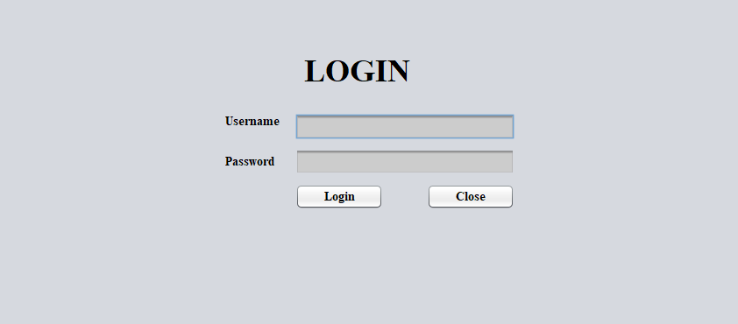

Login Page

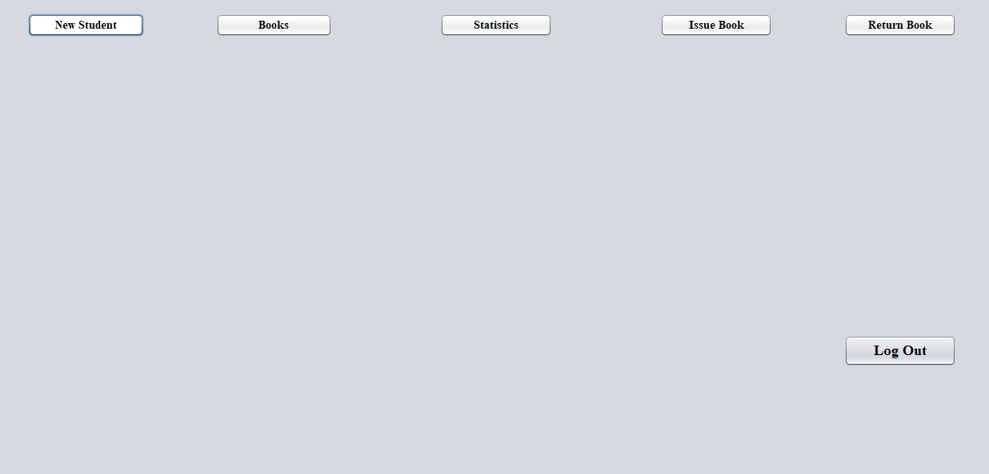

Home Page

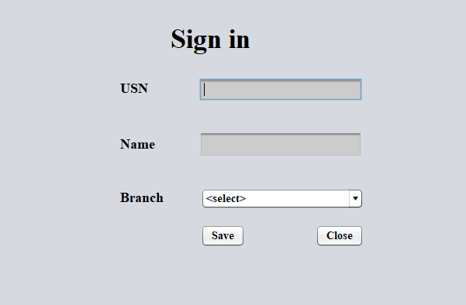

New Student registration

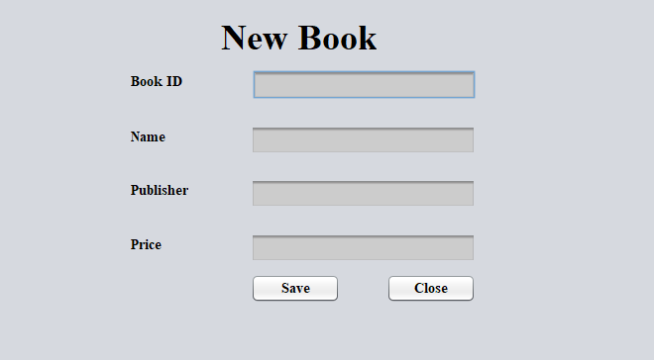

Adding a new book to the DataBase

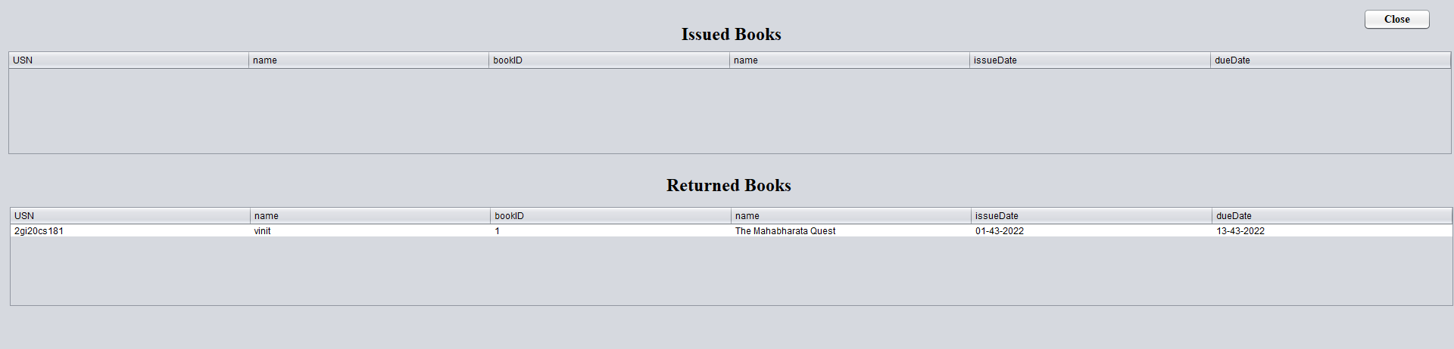

Record of issued books and returned books

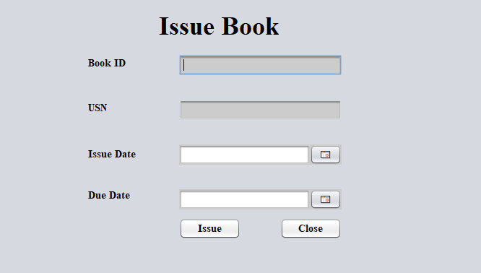

Issue Book page

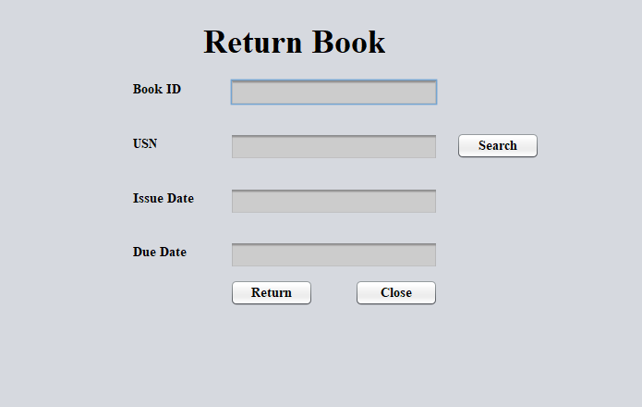

Return book Page

**Conclusion:**

Java is a fascinating programming language that provides its users with a plethora of features like OOP, platform independence, simplicity, GUI based programming, etc. One such feature is creating robust applications using the Swing toolkit provided by **Java Foundation Classes**. This can be used to create lightweight visual components for simple applications, such as EMI calculator, tax calculator, billing systems, record management systems, etc.

**References:**

[1] HERBERT SCHILDT & DALE SKREIN , JAVA FUNDAMENTALS A COMPREHENSIVE INTRODUCTION, TMH, SPECIAL INDIAN EDITION.

[2] KATHY SIERRA & BERT BALES, HEAD FIRST JAVA, O’ REILLY, 2ND EDITION AND ONWARDS.